How to set up CNC with Gradus M1 Pro and Bigfoot drivers
Required tools
- 00x50 Phillips screwdriver
- 1x50 Phillips screwdriver
- Wire stripper
- Multimeter
Required components
1x Grandus M1 Pro https://www.panucatt.com/product_p/gm1pro.htm
3x (or 4x for 2 y axis motors) Bigfoot BSD109A Stepper Driver https://www.panucatt.com/product_p/bsd109a.htm
1xPower supply https://www.smw3d.com/dc-power-supply/
3x (or 4x) Shunts (or jumpers) (also cheap and useful, buy a bunch if you need to pay for shipping anyway) https://www.sparkfun.com/products/9044
1x 3 prong power cable (You can scavange these from just about any old appliance that has 3 prongs or buy them here https://www.smw3d.com/power-cable-for-110v-power-supply/ )
1x High retention USB (male) to USB (male) https://www.smi-elec.com/product/00/us-2ab6/USB-2.0-AB-MM-6-DEVICE-CABLE-BLACK-PN-US-2AB6-
22 gauge wire (Its cheap and sucks when you need it and don’t have it so buy plenty) https://www.smw3d.com/22-gauge-wire-for-endstops-motors-and-sensors/
1x PC computer with USB port
Instructions
- Basic wiring
  - Power Supply
    - Make sure the power supply is set to your local voltage (either 115V or 230). The switch should be on the side of the power supply.
    - Determine live, ground and neutral pins on your 3 pronged cord.
      - Using the multimeter as an Ohmmeter on the 200 setting, touch one lead from the multimeter to a prong and then the corresponding wire is the one that reads anything but infinite resistance or overload.
      - Black is usually live, white is usually neutral, green is usually ground.
    - Wire the 3 pronged cord into the appropriate power supply ports.
    - DON’T FORGET THE GROUND‼‼!
  - Test power supply
    - Plug in power supply to wall outlet.
    - Use the multimeter as a voltmeter to test the voltage between the “V+” output and the “V-“ port on the power supply.
    - You can adjust the voltage by turning a small screw probably near the power ports.
  - Connect power supply
    - Run a 22 gauge wire from an output slot on the power supply to the “V+” port on the Grandus M1 (see diagram and look for “power input” in red letters)
    - Run 22 gauge wire from the “V-“ port on the power supply to the “GRD” port directly beside the “V+” port on the Grandus M1.
- Wiring Bigfoot drivers
  - Take the Bigfoot drivers and place them on the pins for each motor on the Grandus M1 Pro.
  - Place the cooling fins on the drivers as seen on product images.
  - Connect the Vref pins using jumpers (shunts) seen in figure 2.
  - Adjust the Vref potential by turning the “Vref adjust trim pot” screw seen in figure 2 to 0.70-0.75V. You can test this potential with the multimeter by comparing the screw to the ground GRD.
- Install Grbl 1.1 on Grandus M1 Pro
  - Download Arduino IDE
    - https://www.arduino.cc/en/Main/Software
  - Remove grbl library from Arduino
    - Search in PC /Documents/Arduino/Library
    - Delete the folder “grbl”
  - Download grbl 1.1 “Source code (zip)”
    - https://github.com/gnea/grbl/releases
    - Unzip the download and you'll have a folder called grbl-XXX, where XXX is the release version.
  - Launch Arduino IDE which you configured in step 1.b.
    - NOTE: Make sure you have the most recent version
  - Configure Arduino IDE for Grandus M1 Pro
    - Under tools>Port: Make sure the correct port (the one connected to your Grandus M1 Pro) is selected. [mine was “COM3”]
    - Under tools>Board: Select “Arduino Pro or Pro Mini”
    - Under tools>processor: Select “ATMega 328p (5V, 16 MHz)”
    - Under tools> Programmer: “AVRISP mkll”
  - Open the GrblUpload Arduino example.
    - Click the File down-down menu, navigate to Examples->Grbl, and select GrblUpload.
  - Compile and upload Grbl to your Arduino.
    - Connect your Arduino Uno to your computer.
    - Click the Upload, and Grbl should compile and flash to your Arduino.
- Download and configure grbl-panel
  - Download source zip from https://github.com/gerritv/Grbl-Panel/releases
  - Extract the file and run the .exe application.
  - Under the “grbl” heading in the center select the port connected to the Grandus M1. Select 115200 from the options just below the port.
  - Click connect.
- Connect stepper motors
  - Determine pairs of coils from each stepper motor, the colours may vary between suppliers.
    - Each wire in a 4- or 8-lead stepper motor is associated with one end of a coil. The first thing is to find out which wires are on the same coil. There is a simple way to do this: pick two random wires, and measure the resistance between them. If you get a finite value (on the order of a few ohms) then these wires are on the same coil (call them A1/A2 or B1/B2). Continue until you have the wires paired up.
  - Test polarity of stepper motor leads
    - Connect each pair into the A1, A2, B1, B2 ports for the X stepper motor seen in figure 1.
    - In grbl-panel, jog the x-axis by pressing the “+X” button.
    - If the motor spins, you have picked one coil from each phase. Good. If the motor doesn’t spin, the coils are on the same phase, flip A1/A2 around. (Ie. Put your “A1” wire into the “A2” port and vice versa).
- Try it out.

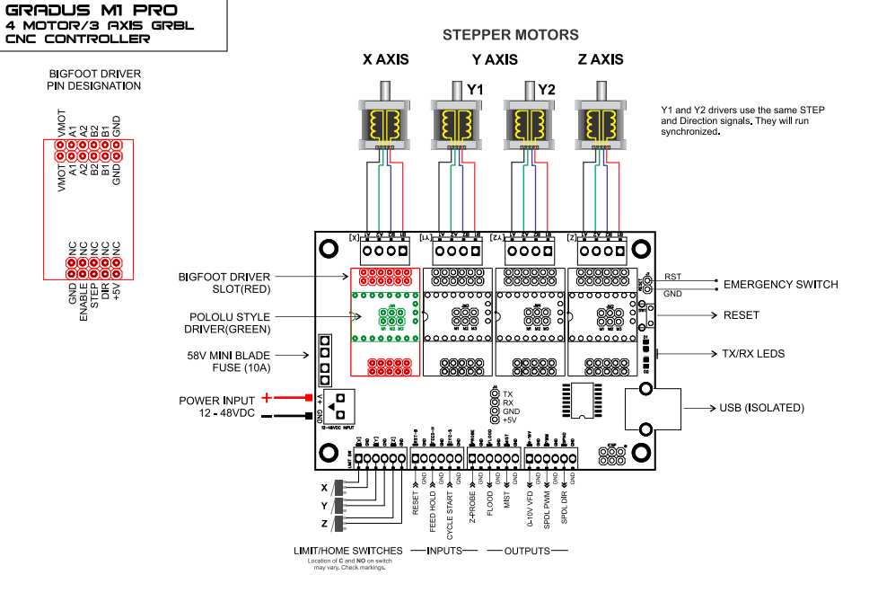
Figure 1. Wiring diagram for Gradus M1 Pro
http://files.panucatt.com/datasheets/m1pro.pdf
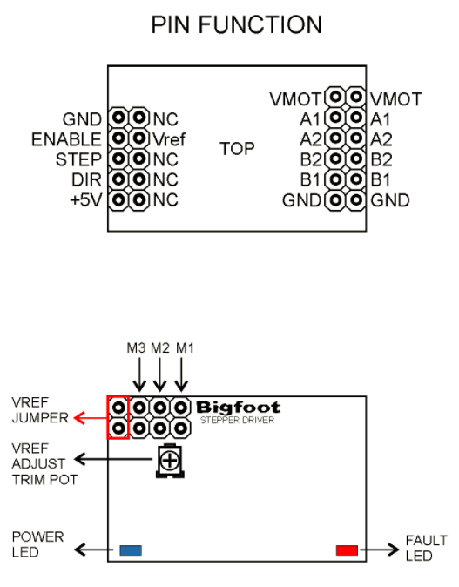
Figure 2. Wiring diagram for Bigfoot stepper controller
https://s3.amazonaws.com/cdn.freshdesk.com/data/helpdesk/attachments/production/1039554827/original/pins.png?1458813183
Thanks to Scotty Orr for previous work. See his threads here: https://openbuilds.com/threads/gradus-m1-pro-information.10164/
Also see Parker for a more in-depth tutorial on stepper motors: http://parkermotion.com/dmxreadyv2/faqsmanager/faqsmanager.asp?question=1008

